

CS4135 – Software Architectures Project
Assignment 3

Team members
# | Name | Student ID
1 | Peile Li | 22305319
2 | Tianxing Fan | 20100035
3 | Hongtao Zhu | 20282958

Department of Computer Science and Information Systems
Faculty of Science and Engineering
University of Limerick

Table of Contents
1.Introduction of the project 4
1.1 Enterprise domain and problem space 4
1.2 Goals of the architecture effort 4
1.3 Summary of bounded contexts 4
1.4 Chosen architectural style 4
2.Contribution 5
3.Strategic Architecture Development 6
3.1 Method 6
3.2 Steps we performed 6
4.Design of architecture based on Model Driven Design 8
A4. Inter-Context Contracts 11
5.Event Storming & Domain Storytelling 14
5.1Event Storming Outcomes and Evidence 14
5.2 Translation of Insights 14
5.3 Domain Storytelling 15
5.4 Facilitation & Evidence 16
6.Architecture Implementation 17
C2. Service Discovery 17
C3. Centralized Configuration 18
C4. Resilience Patterns 18
C5.Integration & Tests 20

1.Introduction of the project

1.1 Enterprise domain and problem space
The system sits in the online food ordering delivery domain. Multiple independent actors—customers, restaurants, delivery drivers, and payment processing—must coordinate without being folded into one monolith. The problem space includes: browsing menus and placing orders, taking payment, assigning and tracking delivery, and notifying users—operations that span different business capabilities and need distributed coordination, fault tolerance, and clear ownership of data and workflows.

1.2 Goals of the architecture effort
The architecture effort aims to decompose the domain into deployable services that have clear boundaries and use separate databases where that separation is appropriate. It exposes a single entry point for clients through an API Gateway, while internal services remain reachable through service discovery (Eureka). The design coordinates cross-cutting flows from order creation through payment, delivery, and notifications by using asynchronous messaging (RabbitMQ) and patterns that fit distributed transactions (for example Saga-style compensation). It supports independent evolution and scaling of demanding paths such as orders, payments, and delivery. Finally, it provides a realistic learning target for distributed systems based on microservices, events, and resilient integration, rather than a single layered CRUD application.

1.3 Summary of bounded contexts
Bounded context | Responsibility
Identity & user | Accounts, authentication, roles (user-service).
Restaurant catalog | Restaurants, menus, catalog data (restaurant-service).
Ordering | Order lifecycle, ratings, discounts (order-service).
Payments | Payment processing and payment-related events (payment-service).
Delivery | Drivers, delivery workflow and status (delivery-service).
Notifications | User-facing notifications driven by domain events (notification-service).

1.4 Chosen architectural style
The solution adopts a microservices style: independently deployable Spring Boot services named user, restaurant, order, payment, delivery, and notification, together with a common module for shared code. The client–server model places a React + Vite single-page application on the client side and exposes HTTP APIs from the backend. An API Gateway (api-gateway) acts as the single external façade that routes requests to the appropriate services. A broker-based event-driven architecture uses RabbitMQ so services publish and consume events across flows such as ordering, payment, delivery, and notifications. Service discovery is provided by Eureka, which lets each service register and discover peers at runtime. Taken together, these choices combine microservices, client–server, gateway, and broker-centric event-driven integration; within each service, the implementation still follows a familiar layered Spring Boot structure (controllers, services, and repositories).

2.Contribution
A1. Ownership & Division of Bounded Contexts
Name | Work area | Description
Peile Li | Full-stack API integration | integration between the React client and the Spring Boot services.  together with platform wiring (e.g. Eureka, Gateway, Docker Compose, CI) so the stack runs end-to-end.
Tianxing Fan | Frontend UI/UX, page design and development | presentation layer: layout, navigation, role-specific screens, and interaction logic on the client. also work on the notification microservice so that domain events translate into user-visible alerts, keeping UI behaviors and server-side notification logic aligned.
Hongtao Zhu | Backend microservice development | server-side features in services such as delivery and payment, including REST APIs, persistence, and messaging hooks where required. unit and service-level tests to lock down behaviour and support safe refactors during integration.

Code Repository: PeileLi/CS4135-grp-project
Wiki page：Home · PeileLi/CS4135-grp-project Wiki

3.Strategic Architecture Development

3.1 Method
We combined domain-driven thinking with incremental delivery as follows:
- Bounded contexts first. We aligned responsibilities with six areas (users, restaurants, orders, payments, delivery, notifications) and we recorded relationships in our architecture materials
- Architecture style selection. We chose microservices because the domain separates cleanly by actor and transaction type, and we combined client–server, an API Gateway, Eureka, and RabbitMQ for parts of the flow that need asynchronous coordination.
- Modular backend layout. We use a Maven multi-module backend: common, eureka-server, api-gateway, and one Spring Boot application per bounded context. Each service is a separate deployable unit (its own pom.xml, Dockerfile, and application.yml), so we evolve the design by adding or adjusting services and contracts—not by collapsing the domain into a single runtime.
- Contract-led integration. We expose synchronous operations through REST and the gateway; we use RabbitMQ for event-style steps (payment, delivery, notifications). We share payloads in backend/common (OrderEvent, PaymentEvent, DeliveryEvent, shared error types) so publishers and consumers stay aligned.
- Environment parity. We use docker-compose.yaml so PostgreSQL, RabbitMQ, Eureka, the gateway, all services, and the frontend start together on a shared network for repeatable demos and debugging.

3.2 Steps we performed
Step | What we did | Concrete outcome
1 | We agreed the domain and system goals. | In Our README.md describes the online food order & delivery problem, actors, and aims (microservices, event-driven flows, Saga-style distributed transactions as stated there).
2 | We mapped bounded contexts to services. | Six contexts match user-service, restaurant-service, order-service, payment-service, delivery-service, notification-service
3 | We fixed integration styles: REST behind the gateway, PostgreSQL per service via JPA, RabbitMQ where events apply. | Each business service pom.xml includes Spring Web, Eureka client, JPA + PostgreSQL, and Spring AMQP where messaging is used; settings live in each application.yml.
4 | We scripted platform infrastructure. | docker-compose.yaml brings up PostgreSQL, RabbitMQ, eureka-server, api-gateway, all microservices, and frontend
5 | We modularised the backend and containerised it. | Parent backend/pom.xml declares modules common, eureka-server, api-gateway, and the six domain services; each service has a Dockerfile under its folder for image builds used by Compose.
6 | We implemented vertical slices (HTTP + persistence + messaging as needed). | Each service contains controllers, services, repositories, and event publishers/consumers (for example under messaging in order, payment, delivery, notification).
7 | We wired cross-service flows with shared events. | backend/common holds OrderEvent, PaymentEvent, DeliveryEvent (and shared exception/DTO types); services publish/consume to support flows such as order → payment → delivery → notification
8 | We integrated the React + Vite client with the gateway. | The frontend/ app centralises HTTP in frontend/src/services/ (for example api.js uses a /api base URL with Axios interceptors for JWT and X-User-Id); deployment uses GATEWAY_PORT (8080) in .env / Compose when routing traffic to the gateway.
9 | We automated build/test and ran manual E2E checks. | GitHub Actions (.github/workflows/ci-cd.yml) runs Maven tests on pushes/PRs to main / develop

4.Design of architecture based on Model Driven Design
Based on our microservices architecture, we divided the system into three core bounded contexts. Each team member takes full ownership of one context, ensuring clear responsibilities from design to deployment, with cross-context dependencies clearly acknowledged in our repository. We utilized UML class diagrams to document the tactical design of each bounded context, strictly adhering to DDD building blocks (Entities, Value Objects, Aggregates, Repositories, Domain Services, and Domain Events).
1.User Identity & Access Context
The Identity & Access Context is responsible for managing user identity, authentication, and authorisation across the entire system. It acts as the upstream context for all other bounded contexts — every service relies on the JWT token issued here to identify the caller and enforce role-based access control.
This context handles three core responsibilities:
- User Registration & Profile Management — A User is the sole aggregate root. It encapsulates personal information (name, email, address) and an assigned UserRole (CUSTOMER, RESTAURANT_OWNER, DELIVERY_DRIVER, ADMIN). Registration enforces email uniqueness and password hashing (BCrypt) as domain-level invariants.
- Authentication — The AuthenticationService (domain service) handles login by verifying credentials and issuing a signed JWT. The token carries userId and role as claims, forming the Published Language that all downstream contexts consume without calling this service at runtime.

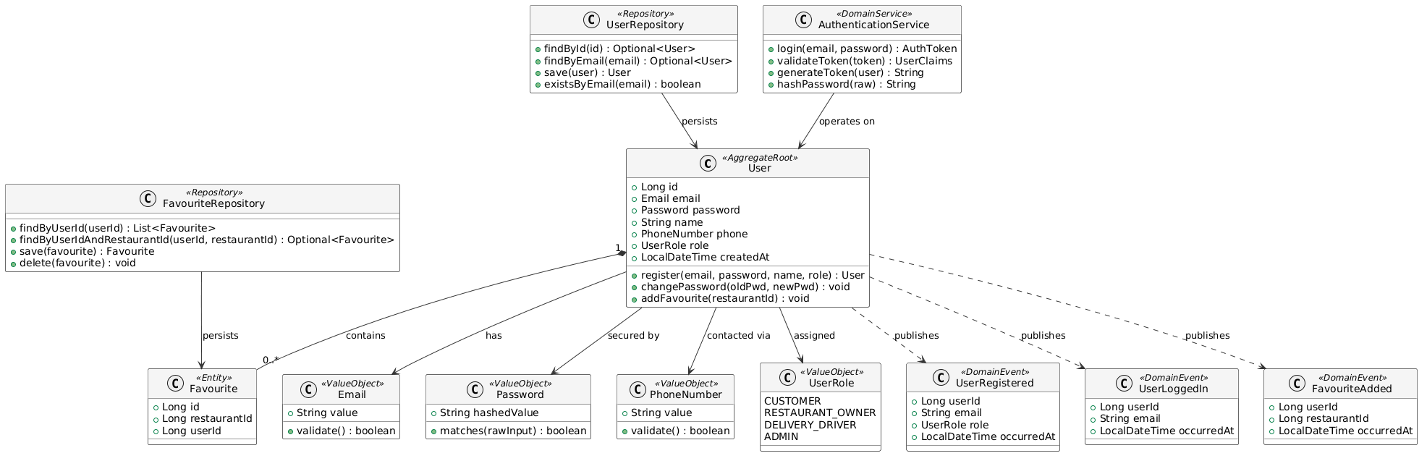
Invariants:
- email must be unique across all users — enforced by DB unique constraint
- password is always stored hashed
- role must be assigned at registration and cannot be changed by the user — only by an ADMIN.
2.Order Fulfillment Context
For the Order Fulfillment Context, 'Order' was the natural choice. Managing operations through the Order aggregate ensures consistency between the order status and its items (especially for total Amount calculation) and prevents invalid state transitions..
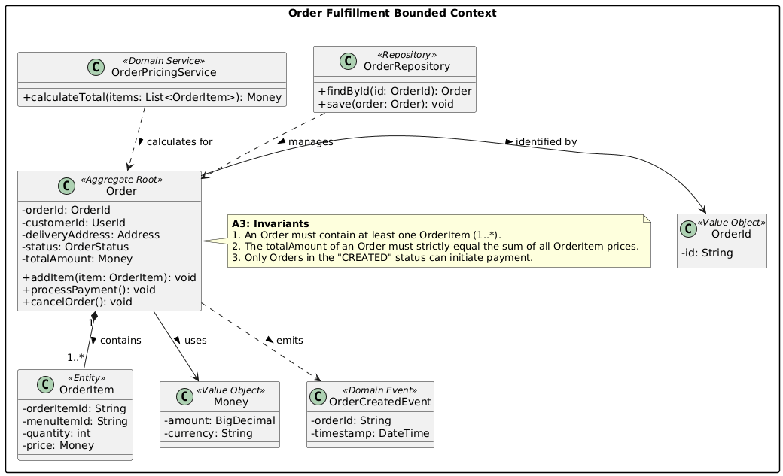
Invariants Enforced:
- AnOrder must contain at least one OrderItem.
- The totalAmount must strictly equal the sum of all item prices.
- Payment can only be initiated when the order is in the "CREATED" state.

3. Restaurant & Catalogue Context
In the Restaurant & Catalogue Context, we designed 'Restaurant' as the core aggregate. We realized early in the design phase that operations like modifying menus or accepting incoming orders depend entirely on whether the restaurant is actually open. Routing these actions through the Restaurant aggregate made the most sense to enforce this rule.
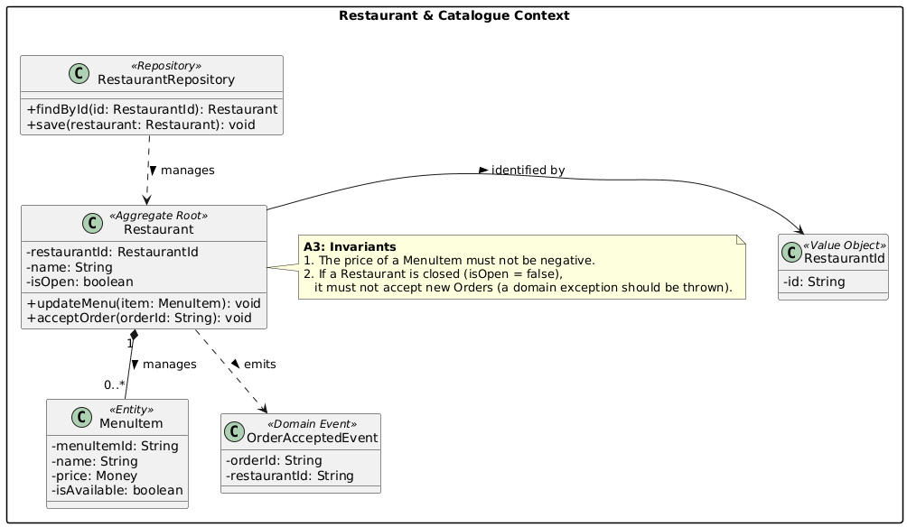
Invariants Enforced:
- Menuitem prices cannot be negative.
- If a restaurant is closed (isOpen = false), it must automatically reject new incoming orders via a domain exception.
4. Logistics & Delivery Context
DeliveryTask is the Aggregate Root because it controls the strict state machine of the delivery process. Assigning drivers and updating location statuses must be consistent with the current phase of the delivery, which the Task aggregate orchestrates.
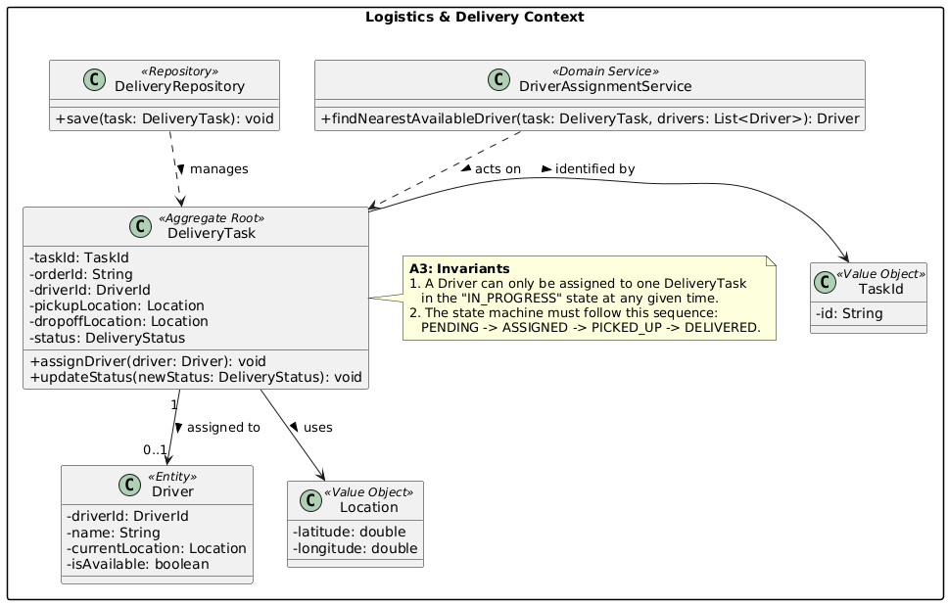
Invariants Enforced:
- Adriver can only be assigned to one active delivery task at a time.
- The status state machine must strictly follow the sequence: PENDING-> ASSIGNED > PICKED_UP-> DELIVERED.

A4. Inter-Context Contracts
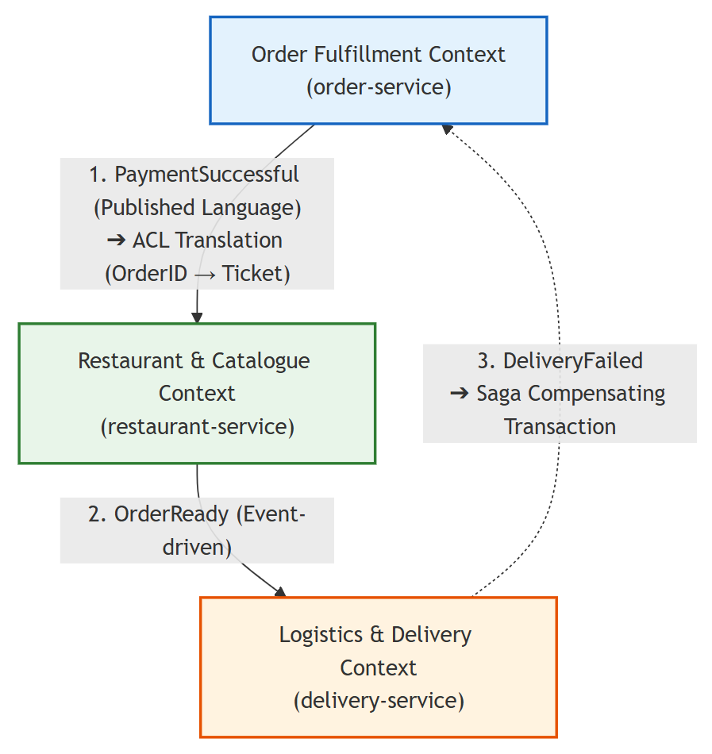
Published Language — Identity & Access → All Contexts
The Identity & Access Context issues a signed JWT token on login. All downstream services validate the token locally using the shared JWT_SECRET; no service calls User Service at runtime. The token carries userId and role, which form the system-wide published language for identity.
Example:
{ "sub": "user@example.com", "userId": 1, "role": "CUSTOMER", "exp": 1712086400 }
Synchronous REST Contracts
Publisher | Endpoint | Consumer | Contract
Restaurant | GET /api/restaurants/{id} | Order | RestaurantDTO { id, name, open, active }
Restaurant | GET /api/restaurants/{id}/menu-items | Order | List<MenuItemDTO> { id, name, price, available }
Order | POST /api/orders | Frontend | CreateOrderRequest { restaurantId, items[], deliveryAddress }
Order | GET /api/orders/{id} | Frontend | OrderDTO { id, status, totalAmount, items[] }
Payment | POST /api/payments | Frontend | PaymentRequest { orderId, amount, paymentMethod }
Delivery | GET /api/deliveries/order/{orderId} | Frontend | DeliveryDTO { id, status, driverName }
The Order Context stores restaurantName and menuItemName as snapshots at order placement — it never holds a live reference to the Restaurant model, preventing tight coupling across context boundaries.
Asynchronous Event Contracts (RabbitMQ)
Publisher | Routing Key | Event Schema | Subscriber
Order | order.created | OrderEvent { orderId, userId, restaurantId, totalAmount, deliveryAddress } | Payment, Delivery, Notification
Payment | payment.completed | PaymentEvent { paymentId, orderId, userId, amount, status } | Order (ACL), Notification
Payment | payment.failed | PaymentEvent { paymentId, orderId, userId, reason, status } | Order (ACL), Notification
Delivery | delivery.updated | DeliveryEvent { deliveryId, orderId, userId, status, driverName } | Order (ACL), Notification

Anti-Corruption Layers (ACL)
- Order Context — receiving Payment events:
OrderEventConsumer translates PaymentEvent into Order domain calls (confirmOrder() / cancelOrder()). The Order aggregate has no knowledge of PaymentEvent or payment vocabulary.
- Order Context — receiving Delivery events:
OrderEventConsumer maps DeliveryEvent.status to OrderStatus (PICKED_UP → DELIVERING, DELIVERED → DELIVERED). The Order aggregate never imports any Delivery domain type.
- Notification Context — receiving all upstream events:
NotificationEventConsumer translates incoming event payloads into the Notification context's own NotificationType vocabulary before creating Notification aggregates. No upstream domain class is referenced inside the Notification model.

5.Event Storming & Domain Storytelling

5.1Event Storming Outcomes and Evidence
To discover domain knowledge and map out our asynchronous workflows, we conducted an Event Storming session. This process defined the flow of domain events, commands, policies, and actors from order placement to final delivery, including hotspots and conflict resolutions. Evidence: https://github.com/PeileLi/CS4135-grp-project/wiki/Meeting
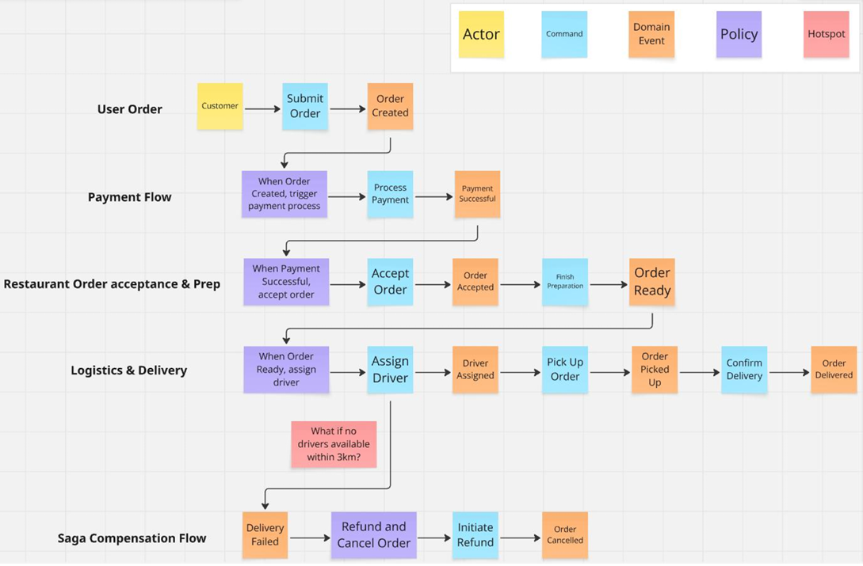

5.2 Translation of Insights
After the event storming session, the team reviewed the outputs and translated the key findings into backlog items tracked on the project kanban board. Items were categorised as either completed within this iteration or deferred to future work.
The main changes implemented as a result of the session were: adding state-transition validation to the Order aggregate, wiring up the payment failure compensation path via OrderEventConsumer, and connecting delivery status updates to order status through the same consumer. A Rating entity and a Discount entity were also added to the Order Context after the team identified that post-delivery feedback and promotional pricing were missing from the original model.
Items deferred to future iterations include real-time driver location tracking and multi-channel notifications (email/SMS). Both were acknowledged as useful but outside the scope of the current deadline. They remain on the backlog and the existing architecture supports adding them without significant rework.

5.3 Domain Storytelling
To explore how the system behaves from the perspective of each actor, we wrote a set of domain stories using the language of the domain. Each story focuses on a specific domain and traces how the surrounding subdomains participate. We structured the system around one core domain and several subdomains:
- Core Domain — Order Management: The primary business activity; placing, tracking, and completing orders is the central value of the system.
- Supporting Subdomain — Restaurant: Manages restaurant availability and menu content; directly supports order placement.
- Supporting Subdomain — Payment: Handles charge and refund processing; required for every order transaction.
- Supporting Subdomain — Delivery: Manages driver assignment and delivery tracking; fulfils the physical side of each order.
- Generic Subdomain — Identity & Access: Provides authentication and role management; a commodity capability shared by all other subdomains.
- Generic Subdomain — Notification: Sends status updates to users; a cross-cutting concern triggered by events across all other subdomains.
Example: Placing and Completing an Order
Primary Domain: Order Management (Core Domain)
Subdomains involved: Restaurant · Payment · Delivery · Notification · Identity & Access
Actors: Customer · Restaurant Owner · Delivery Driver
A customer logs into the system — the Identity & Access subdomain authenticates the request and issues a token identifying the user as a CUSTOMER. The customer browses the restaurant list provided by the Restaurant subdomain, selects a restaurant, and reviews the available menu items. An order is submitted with the selected items and a delivery address, entering the Order Management core domain in PENDING state.
The Payment subdomain receives the order.created event and processes the charge. On success, it publishes PaymentCompleted. The Order domain receives this via its ACL and transitions the order to CONFIRMED. The Notification subdomain sends the customer an in-app confirmation.
The restaurant owner sees the new order on the merchant dashboard, confirms it, and progresses the status through PREPARING to READY. Concurrently, the Delivery subdomain receives the same order.created event and assigns an available driver, publishing DeliveryAssigned. The driver picks up the order (PICKED_UP) and completes the delivery (DELIVERED). The Order domain is updated through the delivery ACL, and the Notification subdomain sends a final delivery alert to the customer.
Domain Events: OrderPlaced → PaymentCompleted → OrderConfirmed → OrderStatusUpdated(PREPARING) → OrderStatusUpdated(READY) → DeliveryAssigned → DeliveryPickedUp → DeliveryCompleted → OrderStatusUpdated(DELIVERED) → NotificationSent

5.4 Facilitation & Evidence
The team used GitHub Project as the primary tool for tracking work throughout this phase. All backlog items derived from the event storming session were added to the project board, assigned to team members, and updated as work progressed. The board provided visibility into what was in progress, what was completed, and what had been deferred.
GitHub Project Kanban: Backlog · Food Delivery System Development

6.Architecture Implementation
Weimplemented the system using a Spring Boot (Java 21) multi-module microservices architecture. Each service aligns strictly with its context's model and enforces its invariants.
- order-service (Order Fulfillment)
- restaurant-service (Restaurant & Catalogue)
- delivery-service (Logistics & Delivery)
- CoreDomains: user-service & payment-service
Each service maintains its own PostgreSQL database schema to ensure strict data isolation.
Build & Run Instructions:
The system is fully containerized and can be easily deployed using Docker Compose. By running docker-compose up--build-d, all infrastructure components (PostgreSQL, RabbitMQ, Eureka) and microservices are automatically built and orchestrated. For local development and testing, services can also be compiled via Maven (mvn install-DskipTests) and executed individually. Detailed environment configurations, service port mappings, and testing commands are thoroughly documented in our README.md at the root of our GitHub repository
Service Package Structure (example: order-service):
order-service/
├── src/main/java/com/example/orderservice/
│ ├── model/ # Domain entities (Order, OrderItem, OrderStatus, ...)
│ ├── repository/ # Spring Data JPA repositories
│ ├── service/ # Domain & application services
│ ├── controller/ # REST controllers
│ ├── messaging/ # RabbitMQ producers & consumers
│ └── config/ # RabbitMQ & application config

C2. Service Discovery
Technology: Netflix Eureka (Spring Cloud Netflix)
All microservices register with the Eureka Server on startup. The API Gateway uses Eureka to resolve service instances via lb:// (load-balanced) URIs — no hardcoded host/port values.
Eureka Server Configuration:
# eureka-server application.yml
server:
port: 8761
eureka:
client:
register-with-eureka: false
fetch-registry: false

Service Registration (all microservices):
# application.yml (each microservice)
eureka:
client:
service-url:
defaultZone: ${EUREKA_URL:http://localhost:8761/eureka/}
instance:
prefer-ip-address: true

C3. Centralized Configuration
Approach: Environment-variable-based configuration via .env file and Docker Compose environment blocks, providing environment separation between development and production.
.env file (version-controlled template as .env.example):
# Ports
EUREKA_PORT=8761
GATEWAY_PORT=8080
FRONTEND_PORT=5173
POSTGRES_PORT=5432
RABBITMQ_PORT=5672
RABBITMQ_MANAGEMENT_PORT=15672

# Eureka
EUREKA_URL=http://eureka-server:8761/eureka/

# Database
SPRING_DATASOURCE_URL=jdbc:postgresql://postgres:5432/cs4135db
SPRING_DATASOURCE_USERNAME=postgres
SPRING_DATASOURCE_PASSWORD=postgres
POSTGRES_USER=postgres
POSTGRES_PASSWORD=postgres
POSTGRES_DB=cs4135db

# Security
JWT_SECRET=your-secret-key-here

# CORS
CORS_ALLOWED_ORIGINS=http://localhost:5173

C4. Resilience Patterns
While our core transaction flow relies on asynchronous messaging (RabbitMQ), synchronous inter-service calls (e.g., Order Service fetching Restaurant availability via OpenFeign) are protected using Resilience4j.
- Circuit Breaker & Fallback: We applied the @CircuitBreaker annotation.
- Timeouts &Retries: Configured a 2-second timeout and a 3-attempt retry policy (@Retry) for transient network glitches.
Resilience Testing: We deliberately killed the restaurant-service container during a transaction to test Resilience4j. After adjusting the timeout threshold to 2 seconds, the logs showed the circuit breaker transitioning from CLOSED to OPEN. Observation Evidence:
Observation Evidence:
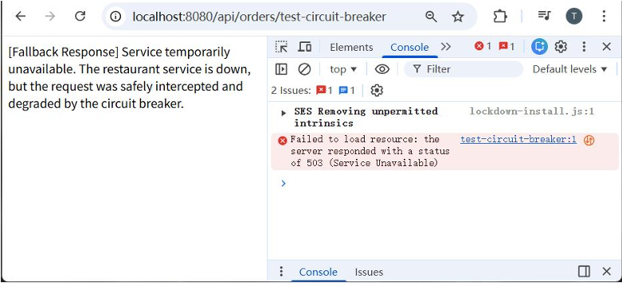
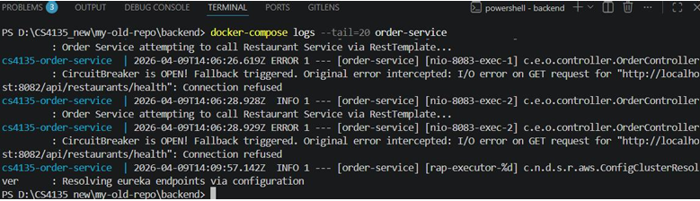
Asynchronous Decoupling (RabbitMQ)
The Choreography Saga pattern via RabbitMQ provides inherent resilience: if the Payment Service is temporarily unavailable, the order.created message remains in the queue and is processed when the service recovers — no message is lost.
Demonstrated Failure Scenario:
1. Stop payment-service container
2. Place a new order via frontend → Order is created (PENDING)
3. order.created event queued in RabbitMQ
4. Restart payment-service → Message is consumed; payment is processed
5. Order status transitions normally

C5.Integration & Tests
Integration was verified by running the full system via Docker Compose and manually tracing the complete order lifecycle from registration through to delivery. The test covered the interaction between all six services and confirmed that events published by one service were correctly consumed and acted upon by the others.
Starting from user registration, a JWT token was successfully issued by the User Service and accepted by all downstream services through the API Gateway. A customer was able to browse the restaurant list, view menu items, and place an order. On order placement, the Order Service published an order.created event to the RabbitMQ exchange. The Payment Service consumed this event, processed the payment, and published payment.completed. The Order Service received this via its OrderEventConsumer and updated the order status to CONFIRMED. The Delivery Service, also subscribed to order.created, created a delivery record and assigned an available driver. As the driver progressed the delivery through PICKED_UP to DELIVERED, the Delivery Service published delivery.updated events, which the Order Service consumed and used to update the order status to DELIVERING and then DELIVERED. Throughout the flow, the Notification Service received events from multiple sources and created in-app notification records for the customer at each stage.
Inter-service communication was tested through the API Gateway using HTTP requests against the published REST endpoints. The RabbitMQ Management UI (http://localhost:15672) was used to confirm that events were being published to the correct exchange and routing keys, and that queues were being consumed without message loss. Service logs provided an additional trace of each event being published and received across the system.
A GitHub Actions CI pipeline is configured in .github/workflows/ci-cd.yml and runs on every push to the main branch. It compiles all Maven modules, executes unit tests per service, and builds Docker images to verify that the multi-module project builds correctly end-to-end.

